# Machine Name

# INFORMATION GATHERING

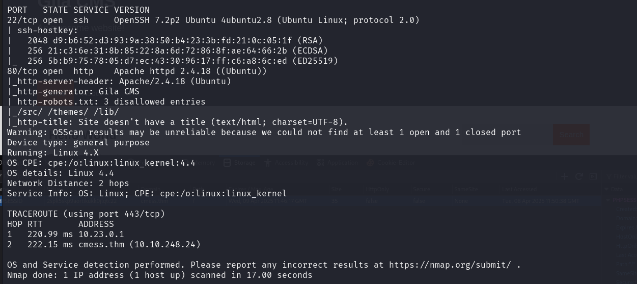

# EXPLOIT